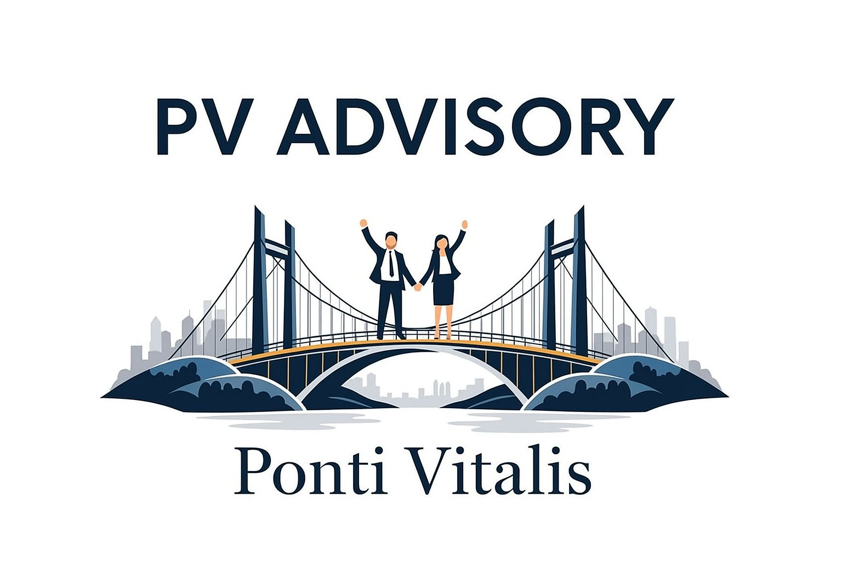
Gen AI Workshop
Compendium
Version 1.0 | 2026
Facilitator: Fredrik Thuresson, PV Advisory
Pillar A | Pillar B | Pillar C

Workshop Overview
Duration | 2–8 Hours (configurable to your team's needs)
Objective | Equip management teams with practical knowledge and tools to leverage Generative AI for business success
Format | Interactive exercises with real-world business applications
Facilitator | Fredrik Thuresson, PV Advisory | fredrik@pvadvisory.se

Introduction
Welcome to the "Generative AI for Business Success" workshop, designed specifically for management professionals. Over the course of this workshop, you will explore practical ways to leverage Generative AI to boost business performance, drive innovation, and streamline work processes. This workbook provides structured exercises and essential resources to guide your learning and maximise workshop outcomes.

Workshop Objectives
- Understand the fundamentals and business applications of Generative AI
- Develop hands-on skills through practical exercises and group activities
- Explore tools, regulatory considerations, and resources for ongoing learning
- Map strategies for integrating AI into your organisation's workflows

Workbook Structure
- Section A – Exercises: Practical Applications of Generative AI
- Section B – AI Tools: List, Descriptions & Links
- Section C – Regulations & Data Privacy
- Section D – Recommended Podcasts
- Section E – Appendix: The R.I.G.H.T. Prompt Framework

Conclusion
Thank you for participating in the Generative AI for Business Success workshop. We hope you gained valuable knowledge, practical skills, and actionable strategies for leveraging AI in your organisation. For continued growth, explore the resources in the appendix, stay current with regulations, and encourage a culture of innovation in your teams.

Next Steps
- Review your workshop notes and share key insights with your colleagues
- Experiment with the AI tools highlighted in the appendix
- Stay informed through the recommended podcasts and ongoing learning resources
- Initiate a pilot project to apply AI in a specific area of your business

Section A: Exercises

Pillar A — Smarter Prompting, Data & Text
Objective: Learn how to communicate effectively with Generative AI models by crafting clear, actionable prompts.

Brief
Introduction to prompt engineering and its impact on AI outputs. You will practise three levels of prompting — from basic to structured — using the R.I.G.H.T. Framework.

Activity: Prompt Makeover – Delivery Delay Email
Scenario: A key customer order has been delayed by one week. You need to communicate this professionally.

- Version A — Write a brief email informing the customer about the delay.
- Version B — Rewrite the email with more context: who you are, tone, key message, and one positive next step.
- Version C — Use the R.I.G.H.T. Framework (see Section E) to craft a complete, professional prompt for the same email.

Discussion: What changed between Version A and Version C? Which response was most useful and why?
Tip: Copy the best AI response and compare it with what you would have written. What did the AI do better?

Pillar B — Better Meetings & Presentations
Objective: Learn to create AI-powered presentations efficiently — from content structure to visual design.

Instructions
- Choose one of the AI presentation tools from the appendix (see the Presentations section in Section B).
- Upload this workshop workbook as your source material or another business PDF file.
- Prompt the tool to create a 6–8 slide presentation that summarises the workshop, its three pillars, and the key tools.
Share your presentation with the group and discuss what worked well and what surprised you.

Discussion: How much time did this save compared to building slides manually? What would you still want to adjust?
Suggested tools: Gamma (gamma.app), Beautiful.ai, PowerPoint with Copilot

Pillar B2 — Better Meetings & Presentations
Objective: How to use Google LM for research and data summary. Learn to create a report, Podcast or a video — from content structure to visual design.

Instructions
- Login to Google LM and add some background data and information about Frontpac. Website, pdf files etc.
- Add the 2 files in the website
Förfrågan
63e15c75-f6d2-4907-a020-ea20a5a443de
Offert Frontpac
c58b35ae-1760-449b-896b-5ad2370bd367
- Ask why shall we as a customer choose Frontpac as our longterm partner.
- Choose one output format presentation, podcast or video presentation and finalize and view the results.
Share your output with the group and discuss what worked well and what surprised you.

Discussion: Can we use something of this in our business forward
Suggested tools: Google LM

Pillar C — Smarter Processes, Solutions & Agents
Objective: Explore how to build simple AI-powered applications without writing a single line of code.

The Claims Assistant – Internal Complaint Manager
Build a complete mini-app with a form, AI logic, data storage, and a live dashboard — solving a real-world pain point your team will immediately recognise.

What the app does
- Categorises the complaint: printing error, dimension discrepancy, delivery failure, or quality defect
- Drafts a professional customer response with the right tone and key information
- Determines internal priority (High / Medium / Low) based on the customer profile and claim nature
- Saves all cases to a centralised dashboard with statistics and resolution tracking

Instructions
- Go to Base44 (https://app.base44.com) and sign in or create a free account.
- Paste the Base44 build prompt from your facilitator into the chat (your facilitator has the full prompt ready).
- Wait 2–3 minutes for the app to be built. Review what was created.
- Test the app: submit a sample complaint and watch the AI categorise it, draft a reply, and assign a priority.
- Group discussion: What would this mean for your business? Where else could you apply this pattern?

Demo tip: Use this scenario — 'Customer received 2,400 units instead of 4,000 of the 5L carton. Production claims the order was fulfilled correctly.' — and watch the AI respond.
Build prompt: Your facilitator will share the full Base44 prompt during the session.

Section B: AI Tools — List, Descriptions & Links
The tools below are organised by category. Each entry includes a short description and a direct link. You do not need to use all of them — select the tools most relevant to your role and workshop pillar.

Chatbots, Research & Deep Analysis
- ChatGPT (OpenAI) The world's most widely used AI assistant for content creation, brainstorming, drafting, and research. https://chat.openai.com/
- Microsoft Copilot AI assistant embedded across Microsoft 365 — Word, Excel, Outlook, Teams — for productivity and workflow automation. https://copilot.microsoft.com/
- Anthropic Claude Advanced AI assistant known for nuanced reasoning, long document analysis, and complex multi-step tasks. https://claude.ai/
- Google Gemini Google's AI model integrated into Workspace (Docs, Gmail, Sheets) for business applications. https://gemini.google.com/
- Perplexity AI AI-powered real-time search and research tool with cited sources — ideal for fact-finding and market research. https://www.perplexity.ai/
- Google NotebookLM Upload your documents and have AI answer questions, generate summaries, and create audio overviews from your own data. https://notebooklm.google.com/

Image Generation, Diagrams & Graphics
- Midjourney Photorealistic and artistic AI image generation via Discord — ideal for marketing visuals and creative briefs. https://www.midjourney.com/
- Adobe Firefly AI creative tools natively integrated with Adobe Photoshop and Illustrator — safe for commercial use. https://www.adobe.com/products/firefly.html
- Microsoft Image Creator Free AI image generation powered by DALL·E, available directly in Bing and Edge. https://www.bing.com/images/create
- Napkin AI Converts text descriptions into clean diagrams, process flows, and visual frameworks instantly. https://www.napkin.ai/
- Ideogram AI image generator with strong text rendering — great for logos, posters, and branded visuals. https://ideogram.ai/
- UX Pilot AI-powered UI design assistance and wireframing tool for product and design teams. https://uxpilot.ai/
- Whimsical AI – whimsical.com AI-assisted flowcharts, mind maps and wireframes. Perfect for drawing processes, structures and flows. If you prompt "draw a customer journey map for a B2B company" it will build it for you. https://whimsical.com/ai

Video & Audio Generation
- Fliki AI Text-to-video and text-to-audio platform with 1,300+ AI voices in 80+ languages. Ideal for training videos, product demos, and social content. https://fliki.ai/
- Guidde Create step-by-step video documentation and tutorials up to 11× faster with AI narration and auto-captions. https://www.guidde.com/
- Runway Professional AI video generation and editing platform used by filmmakers and creative agencies. https://runwayml.com/
- Pika Labs AI-powered video generation from text prompts — bring still images or scripts to life. https://pika.art/
- InVideo AI AI video creation platform for social media, ads, and product content with templates and voiceover. https://ai.invideo.io/
- HeyGen Create AI avatar videos with realistic lip-sync — ideal for CEO messages, onboarding, and localised content. https://www.heygen.com/

Professional Headshots
- BetterPic Generate studio-quality AI professional headshots from your own photos in minutes. https://www.betterpic.io/
- AI Suitup AI-powered professional photo enhancement — add formal attire and polished backgrounds to any selfie. https://www.aisuitup.com/
- Headshot Pro Dedicated AI headshot generator for LinkedIn profiles and business directories. https://www.headshotpro.com/

No-Code App Building & Vibe Coding
- Base44 Describe any app in plain English and watch it get built in minutes — forms, dashboards, AI logic, no code needed. https://app.base44.com/
- Lovable AI-powered web app development — describe your idea and get a deployable app with a real database. https://lovable.dev/
- Bolt.new Full-stack AI app builder — from idea to deployed web application with advanced UI and backend logic. https://bolt.new/
- Cursor AI-powered code editor for developers — write, refactor, and debug code with an AI pair programmer. https://cursor.com/
- GitHub Copilot AI programming assistant embedded in VS Code and other IDEs — suggests code as you type. https://github.com/features/copilot
- Replit Online AI-powered coding and hosting platform — great for rapid prototyping and collaborative development. https://replit.com/

Website Builders
- Wix ADI AI-powered website builder — answer a few questions and get a complete website generated automatically. https://www.wix.com/
- Framer AI Design and publish professional websites with AI-assisted layout and copy generation. https://www.framer.com/
- 10Web AI website builder with managed WordPress hosting — generates and optimises your site automatically. https://10web.io/

Meetings, Transcription & Summaries
- Klang.ai AI meeting assistant that joins calls and delivers accurate Swedish + multilingual transcriptions and summaries. https://klang.ai/
- Otter.ai Real-time meeting transcription with automated action items and searchable notes. https://otter.ai/
- Fireflies.ai AI note-taker that records, transcribes, and analyses meetings across Zoom, Teams, and Google Meet. https://fireflies.ai/
- Microsoft Copilot for Teams Built-in AI assistant that summarises Teams meetings and suggests follow-up actions. https://copilot.microsoft.com/

Presentations
- Gamma AI presentation builder — paste your text or outline and get a fully designed deck in seconds. https://gamma.app/
- Beautiful.ai Smart slide designer that automatically adjusts layouts as you add content. https://www.beautiful.ai/
- PowerPoint with Copilot AI-enhanced presentation creation within the familiar PowerPoint interface (requires M365 Copilot). https://www.microsoft.com/en-us/microsoft-365/powerpoint
- Presentations.ai Automated slide generation from prompts, documents, or URLs. https://www.presentations.ai/

Workflow Automation & Agents
- Make (formerly Integromat) Visual workflow automation — connect apps and automate complex multi-step processes without code. https://www.make.com/
- Zapier Connect 6,000+ apps and automate tasks with AI-enhanced triggers and actions. https://zapier.com/
- n8n Open-source workflow automation with AI nodes — full control, self-hosted or cloud. https://n8n.io/
- Relevance AI Build and deploy AI agents that handle research, outreach, and data tasks autonomously. https://relevanceai.com/
- AI Empower Labs Swedish-developed flexible, secure agent and automation engine — built for enterprise privacy requirements. https://aiempowerlabs.com/

Security & AI Governance
- Tumeryk Real-time AI trust scoring to ensure model integrity and detect anomalous outputs. https://www.tumeryk.com/
- Opaque Confidential AI computing for secure data processing — run AI on sensitive data without exposing it. https://opaque.co/
- Darktrace Cybersecurity powered by self-learning AI — detects and responds to novel threats automatically. https://www.darktrace.com/

Section C: Regulations & Data Privacy
Key Regulatory Considerations
AI adoption in business must be balanced with legal and ethical responsibilities. The following principles apply across most European jurisdictions and are highly relevant for management teams deploying AI.

EU AI Act (2024)
- The EU AI Act classifies AI systems by risk level: Unacceptable, High, Limited, and Minimal risk.
- High-risk AI applications (e.g., HR decisions, credit scoring, critical infrastructure) require documentation, human oversight, and registration.
- Generative AI models like ChatGPT and Claude fall under specific transparency obligations — outputs must be clearly labelled as AI-generated when relevant.
- Penalties for non-compliance can reach €35 million or 7% of global annual turnover.

GDPR & Data Privacy
- Never input personal data (employee, customer, or patient data) into public AI tools without a Data Processing Agreement (DPA) in place.
- Verify whether the AI tool stores or trains on your data — most enterprise tiers offer opt-out options.
- Ensure transparency: if AI is used to make decisions affecting individuals, this must be disclosed.
- Regularly review and update your organisation's AI usage policy as tools and regulations evolve.

Practical Recommendations
- Designate an AI policy owner in your organisation — someone responsible for keeping the team informed and compliant.
- Maintain an internal AI tool register: what tools are used, by whom, and what data is processed.
- Consult legal experts before deploying AI in customer-facing, HR, or financial decision-making contexts.
- Use enterprise or business-tier versions of AI tools when handling any sensitive business information.

Key resource: EU AI Act full text and compliance guidelines
https://eur-lex.europa.eu/legal-content/EN/TXT/?uri=CELEX:32024R1689

Section D: Recommended Podcasts
Stay current between workshops with these curated podcasts covering AI strategy, practical tools, and business transformation.

English-Language Podcasts
- HBR IdeaCast Harvard Business Review's flagship podcast — features AI strategy and leadership episodes with world-class executives. https://hbr.org/podcasts/ideacast
- Practical AI (Changelog) Real-world AI adoption stories, use cases, and lessons learned — highly accessible for non-technical leaders. https://changelog.com/practicalai
- The AI Daily Brief Daily 10-minute updates on the most important AI developments in business and technology. https://podcasts.apple.com/us/podcast/the-ai-daily-brief/id1680633614
- Lex Fridman Podcast In-depth conversations with leading AI researchers, entrepreneurs, and technologists. https://lexfridman.com/podcast/

Swedish-Language Podcasts
- AI-podden Swedish interviews with business leaders and AI experts — focused on practical adoption in Nordic companies. https://www.ai-podden.se/
- Digitalsamtal Covers digital transformation and the role of AI in Swedish organisations — strategic and accessible. https://digitalsamtal.se/
- Snacka om AI Conversational Swedish podcast covering AI trends, tools, and their implications for business and society. https://poddtoppen.se/podcast/1772223397/snacka-om-ai

Tip: Start with one episode per week. Listen during your commute or morning walk — it adds up to significant knowledge over a quarter.

Section E: Appendix — The R.I.G.H.T. Prompt Framework
The R.I.G.H.T. Framework is PV Advisory's structured approach to writing effective AI prompts. By including all five elements, you consistently get higher-quality, more relevant, and more actionable responses from any AI tool.

Letter | What to include in your prompt
R – Role | Assign a role to the AI. Who should it act as? A senior marketing manager? A legal adviser? A customer service expert? This shapes the perspective, tone, and depth of the response.  Example: "You are a senior sales manager at a B2B packaging company with 15 years of experience."
I – Information | Give the AI the context it needs. What does it need to know about your company, the situation, the audience, or the task? The more relevant background you provide, the better the output.  Example: "Our customer Nordic Dryck AB ordered 4,000 units of our 5L BiB carton. The delivery will be delayed by 7 days due to a supplier issue."
G – Goal | State exactly what you want the AI to produce. Be specific about the type of output — an email, a list, a summary, a plan, a presentation script. Vague goals produce vague results.  Example: "Write a professional email informing the customer about the delay, reassuring them of our commitment, and offering a concrete next step."
H – How | Specify the format, tone, length, and structure. Should it be formal or casual? Bullet points or prose? 200 words or 500? In what language? Any specific sections to include?  Example: "Use a professional but warm tone. Keep it under 200 words. Structure it as: opening acknowledgement, explanation, reassurance, next step, and closing."
T – Tweak | Iterate. Your first prompt is rarely perfect — that is fine. Refine based on the output. Ask the AI to adjust the tone, expand a section, make it more concise, or give you a second version.  Example: "Good. Now make the tone slightly warmer and add a sentence about our 30-year track record of reliability."

Complete R.I.G.H.T. Prompt Example
Role:
You are a senior key account manager at Frontpac, a leading B2B packaging manufacturer with 30 years of experience serving food & beverage brands in Scandinavia.

Information:
Our customer Nordic Dryck AB ordered 4,000 units of our 5-litre bag-in-box carton (order #FP-2026-0312). Due to an unexpected raw material shortage at our foil supplier, the delivery will be delayed by 7 days. The customer has a promotional campaign launching in 4 weeks.

Goal:
Write a professional email informing the customer of the delay. The email should maintain trust, demonstrate proactive communication, and propose a clear next step.

How:
Professional but warm tone. Maximum 220 words. Structure: opening, delay explanation (without oversharing internal details), reassurance, concrete next step, professional closing. Write in English.

Tweak:
If the first result is good, ask the AI: 'Now add a line referencing our 99.1% on-time delivery record and make the tone slightly more personal.'

Quick Reference Card
Save this summary and use it as a checklist before submitting any important prompt:

Element | Key Question | Checklist
Role | Who should the AI be? | Job title, expertise level, industry context
Information | What does the AI need to know? | Company, situation, audience, constraints
Goal | What do I want the AI to create? | Output type, topic, specific deliverable
How | In what format and style? | Tone, length, structure, language
Tweak | Is the output good enough? | Iterate: adjust, expand, shorten, rewrite

The R.I.G.H.T. Framework was developed by PV Advisory as part of the "Generative AI for Business Success" workshop programme.

PV Advisory AB | Ponti Vitalis | fredrik@pvadvisory.se

